

**Monika Vaddineni – mxv220020**

**Sriya Namavarapu – sxn220098**

**Nikhil Sai Vemula - nxv220011**

**University of Texas at Dallas**

**MIS 6308.0W3 - System Analysis and Project Management - F23**

**December 8th 2023**

Table of Contents

**1 EXECUTIVE SUMMARY** 4

**2. PROBLEM STATEMENT** 5

**2.1. PROBLEMS and PROPOSED SOLUTIONS** 5

**2.2. OBJECTIVES** 6

**2.3. SCOPE** 6

**3. FUNCTIONAL SPECIFICATION** 7

**4. CONTEXT DIAGRAM** 8

**5. USE CASE DIAGRAMS** 9

**5.1. Reserve A Seat use case** 9

**5.2. Get Bus Schedule use case** 9

**5.3. Driver Check In – Check Out use case** 10

**5.4. Apply Promo Code use case** 11

**6. USE CASE DESCRIPTIONS** 11

**6.1. Use Case description : Reserve A Seat** 11

**6.2. Use Case description : Get Bus Schedule** 12

**6.3. Use Case description : Driver Check In – Check Out** 12

**6.4. Use Case description : Apply Promo Code** 12

**7. BPMN DIAGRAMS** 13

**7.1. BPMN choreography diagram for Reserve A Seat use case** 13

**7.2. BPMN choreography diagram for Get Bus Schedule use case** 14

**7.3. BPMN choreography diagram for Driver Check In - Check Out use case** 14

**7.4. BPMN choreography diagram for Apply Promo Code use case** 15

8. DATA DICTONARY 15

**8.1. Data Dictionary: Reserve a seat** 15

**8.2. Data Dictionary: Get Bus Schedule** 15

**8.3. Data Dictionary: Driver Check-In – Check Out** 16

**8.4. Data Dictionary: Apply Promo Code** 16

**9. CLASS DIAGRAMS** 17

**9.1. Class diagram for Reserve A Seat use case** 17

**9.2. Class diagram for Get Bus Schedule use case** 17

**9.3. Class diagram for Driver Check In – Check Out use case** 17

**9.4. Class diagram for Apply Promo Code use case** 18

**10. SEQUENCE DIAGRAMS** 18

**10.1. Main Sequence diagram** 18

**10.2. Sequence diagram for Reserve A Seat use case** 19

**10.3. Sequence diagram for Get Bus Schedule use case** 20

**10.4. Sequence diagram for Driver Check In – Check Out use case** 21

**10.5. Sequence diagram for Apply Promo Code use case** 22

**11. INTERFACE DESIGN** 23

**12. COMPLETE CLASS DIAGRAM** 28

**13.DATABASE DESIGN** 29

**13.1. Entity Relationship Diagram** 29

**13.2. Database Constraints** 29

**14. SOFTWARE DESIGN** 30

**15.Project Management Deliverables** 35

**15.1. Minutes of meeting and Weekly Tasks** 35

**16. REFERENCES** 40

# **1. EXECUTIVE SUMMARY**

GoPass is among the most straightforward applications for paying for and riding DART. To get you where you need to go in Dallas, Texas, this software will utilise state-of-the-art public transportation and customer amenities designed to improve your financial situation, comfort, and utility. Creating everything DART-capable is a simple process with this application. DART passes, and the next bus schedule from any location are both accessible via the application. Additionally, the application features a travel planner that can assist you in reaching your destination. The convenience allows clients to organize their rail and transit travels. Due to the yearly influx of new students, securing a position on the bus has become an extremely challenging endeavor. Obtaining a bus seat is becoming increasingly difficult, particularly during the morning and afternoon peak hours. Users are, however, unable to view the current location of the vehicle in the event of unforeseen circumstances. We discovered a solution through investigation and testing with the GoPass application: we integrated the additional modules into the app to resolve some of its issues. Users are able to seek for the specific buses that will be operating along their route using the software. They may make a seat reservation for the bus if they discover one with available spaces. Guests were provided with the following payment options following their reservation: cash, credit/debit cards, or GPay. At the beginning of each bus route each day, drivers can update the app with pertinent information such as their starting point, arrival time, and more by utilizing the QR code located on each bus. This enables real-time monitoring of the bus's location. This system would provide notifications to users in the event of any complications or disruptions. Ultimately, the application empowers users to personalize notifications, enabling them to promptly ascertain any travel schedule adjustments or delays. Customers may utilize the promotional codes if they so choose.

# **2. PROBLEM STATEMENT**

# **2.1. PROBLEMS and PROPOSED SOLUTIONS**

Among other things, users of the existing Go Pass app can purchase tickets and examine DART bus route details to facilitate their travel planning. We think there is space for improvement, so we have highlighted two problems with the app and provided fixes below:

1. The existing system lacks the capability for users to make seat reservations for the bus; instead, it merely exhibits the bus schedule for the given route:

When an individual makes comprehensive pre-travel arrangements but reaches a bus stop situated at a considerable distance from their point of departure, they may be required to stand. In certain instances, the bus driver may bypass the crowded stop due to its overcrowding.

2. Live tracking in the bus:

At all times, the application provides the user with restricted information regarding the location of the bus. Unforeseen circumstances such as mechanical failures or collisions prevent the user from overseeing the whereabouts of the bus during the early or late hours. As a consequence, the user encounters difficulty in coordinating their journey.

3. Monetize the GoPass app by promotional marketing strategy:

In-app discount vouchers can be generated for frequent passengers in accordance with their previous travel history.

# **2.2. OBJECTIVES**

* It is recommended that the user select the "Reserve a Seat" alternative, which grants them the ability to pre-book a seat on the bus. They will be provided with a QR code in return, which they are required to scan upon boarding the bus.
* 2.The application provides "Live Tracking" as one of its modules. For this alternative to operate, every vehicle would be equipped with a QR code. The bus driver would scan the code daily at the beginning of service to initiate real-time surveillance from his mobile device. The information obtained via GPS would subsequently be accessible via the application for all registered passengers boarding the bus.
* The app provides promotional codes for ticket discounts to the consumer. Riders may redeem promotional codes in order to obtain discounts on their trips.

# **2.3. SCOPE**

1 An estimate places the total cost of the system at approximately $1,000.

2.Achievement of completion is expected to occur within four to five months.

3.Drivers must be provided with guidance on how to utilize the check-in functionality of their mobile application so that operations can be streamlined and enhanced.

4. Database servers are required to store promotional codes, bus information, and transaction data.

# **3. FUNCTIONAL SPECIFICATION**

1. Using the proposed method, passengers will have the ability to pre-book a seat prior to their visit.

2. Users are able to locate transit routes by performing a search from one location to another.

3. In addition to selecting a bus route, passengers are provided with information regarding available spaces.

4. Following payment, the user is able to select and reserve an available seat.

5. Individuals are granted the capability to monitor the real-time whereabouts of a bus through the live tracking module, which retrieves the mobile GPS location of the driver.

6. The driver must complete the check-in process via the Go Pass mobile application for GPS tracking of the bus to commence using their local location. The driver may scan the bus's unique QR code to initiate live monitoring and check in for the vehicle.

7. Users are able to access a catalog of available promo codes during a transaction. Users are awarded "points" for each transaction of purchasing a ticket or reserving a seat through the "Go Pass" application. These reward points may be applied to the purchase of available discount codes. By utilizing these promotional codes, users can attain discounts on all purchases conducted via the application.

# **4. CONTEXT DIAGRAM**

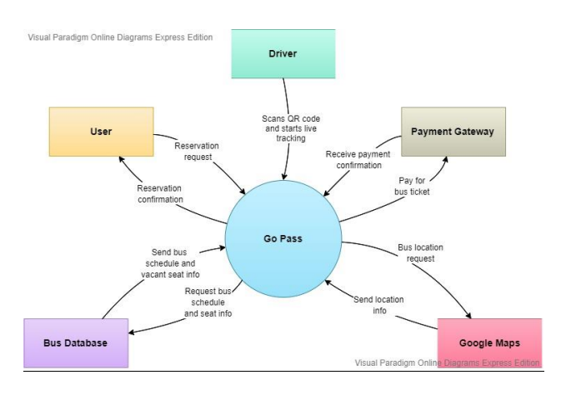

# **5. USE CASE DIAGRAMS**

# **5.1. Reserve A Seat use case**

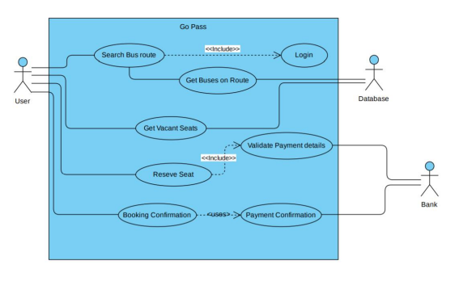

## **5.2. Get Bus Schedule use case**

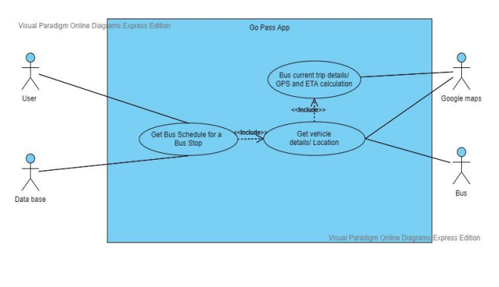

## **5.3. Driver Check In – Check Out use case**

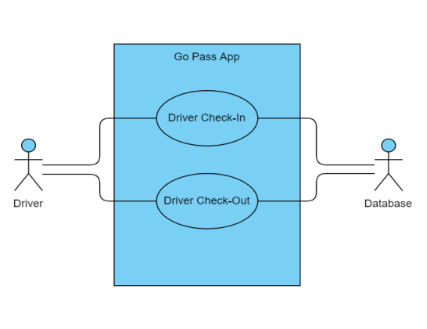

## **5.4. Apply Promo Code use case**

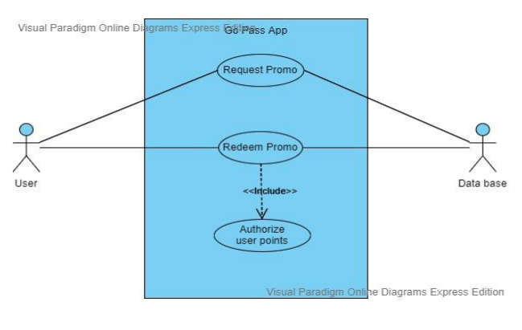

# **6. USE CASE DESCRIPTIONS**

## **6.1. Use Case description: Reserve A Seat**

Name: Reserve A Seat

Description: reserves a seat for the user

Trigger: A user searches bus route and selects vacant seat to reserve

Normal Flow:

1. The user looks up a bus route.

2. Show the buses on the route that was searched.

3. The user chooses a bus

4. Obtain information about available seats for the chosen bus.

5. The user chooses an open seat.

6. User is taken to the payment page.

7. Confirm payment details with the bank.

8. Obtain a bank payment confirmation.

9. Hold the open seat.

10. Update the seta with the database's contents.

11. Send the user a confirmation of their reservation

Exception Flow:

1.a1. If user not logged in, redirect user to Login firs

## **6.2. Use Case description: Get Bus Schedule**

Name: Get Bus Schedule

Description: Get the schedule and live GPS of bus for the user

Trigger: A user searches for bus in a specified bus stop

Normal Flow:

1. A user looks up a bus stop's schedule online

2. Show the bus timetables for the appropriate bus stop.

3. The user chooses a bus

4. Get bus details from the bus database.

5. Get the GPS location from Google Maps using the vehicle's data.

6. From the bus stop, determine your ETA.

7. Give the user the ETA and bus details.

## **6.3. Use Case description: Driver Check In – Check Out**

Name: Driver Check In – Check Out

Description: When driver checks in – the vehicle GPS tracking starts and when driver checks out

– the vehicle GPS tracking ends.

Trigger: The driver checks-in to the app or checks-out of the Go-Pass app

Normal Flow:

1. The driver launches the program and uses the vehicle ID in the QR code form to check in.

2. The GPS tracking of the car activates and goes online.

3. In the application, the driver checks out

4. The GPS tracking of the car ends and is not available.

## **6.4. Use Case description: Apply Promo Code**

Name: Apply Promocode

Description: Apply promocode for the user

Trigger: A user searches for coupons/promocodes and applies it using his/her points

Normal Flow:

1. The user looks for deals and promotions

2. List the available coupons 3. Choose the coupons according to his or her points

4. Verify the points the user has made.

4a. If there are sufficient points, move on to step 5

4b. If the points are insufficient, return to step 3 and provide an error notice.

5. Update the database's user points.

6. Use the promo code

# **7. BPMN DIAGRAMS**

## **7.1. BPMN choreography diagram for Reserve A Seat use case**

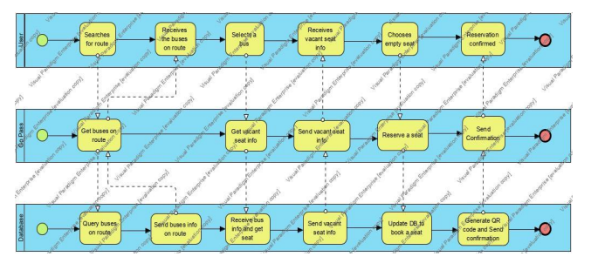

## **7.2. BPMN choreography diagram for Get Bus Schedule use case**

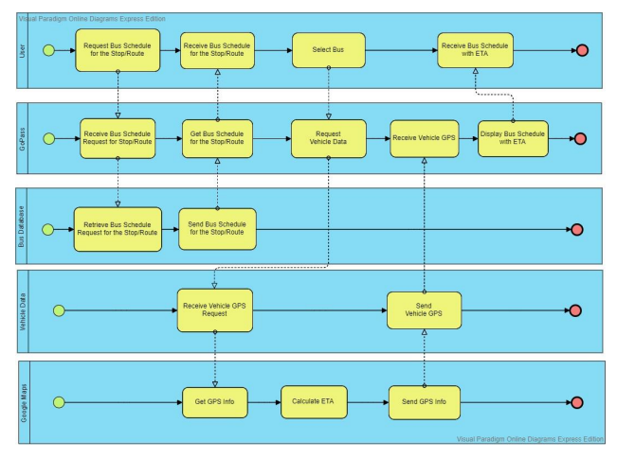

## **7.3. BPMN choreography diagram for Driver Check In - Check Out use case**

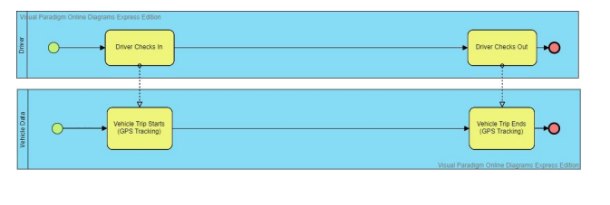

## **7.4. BPMN choreography diagram for Apply Promo Code use case**

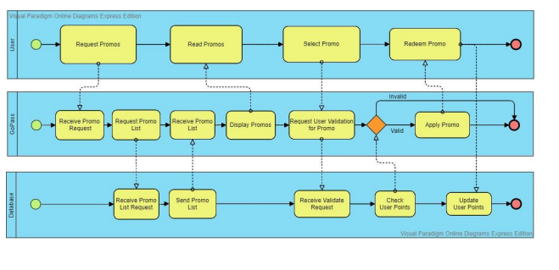

# **8. DATA DICTONARY**

## **8.1. Data Dictionary: Reserve a seat**

Login info = Username + password

Username = [MobileNumber |EmailId]

Password = data element

FromLocation = [Zipcode | GPS Location]

ToLocation = [Zipcode | GPS Location]

Bus Route Data = BusID + FromLocation + ToLocation + 0{LocationOnRoute} + {AvailableSeats} +

ScheduleDate + ScheduleTime + DriverID

User = UserName + Password + Points

Payment = PaymentID + Amount + PaymentDate + PaymentTime

Booking = BookingId + UserName + PaymentID + BusID + BookingDate + TripDate +

FromLocation + ToLocation

## **8.2. Data Dictionary: Get Bus Schedule**

Search Criteria = SearchId + TripDate + RouteId + UserName

Search Data = BusId + TripData + FromLocation + ToLocation + SearchId + UserName

FromLocation = [Zipcode | GPS Location]

ToLocation = [Zipcode | GPS Location]

Bus = BusId + FromLocation + ToLocation + LocationOnRoute + AvailableSeats + ScheduledDate

+ ScheduledTIme + DriveId

## **8.3. Data Dictionary: Driver Check-In – Check Out**

Driver = DriverId + FirstName + LastName + PhoneNumber

Bus Route Data = BusID + FromLocation + ToLocation + 0{LocationOnRoute} + {AvailableSeats} +

ScheduleDate + ScheduleTime + DriverID

FromLocation = [Zipcode | GPS Location]

ToLocation = [Zipcode | GPS Location]

## **8.4. Data Dictionary: Apply Promo Code**

Login info = Username + password

Username = [MobileNumber |EmailId]

Password = data element

User = UserName + Password

Promo = PromoId + PointsRequired + DiscountOffered + Expiry

PromoHistory = UserName + PromoId + RedeemDate + PromoHistoryId

# **9. CLASS DIAGRAMS**

## **9.1. Class diagram for Reserve A Seat use case**

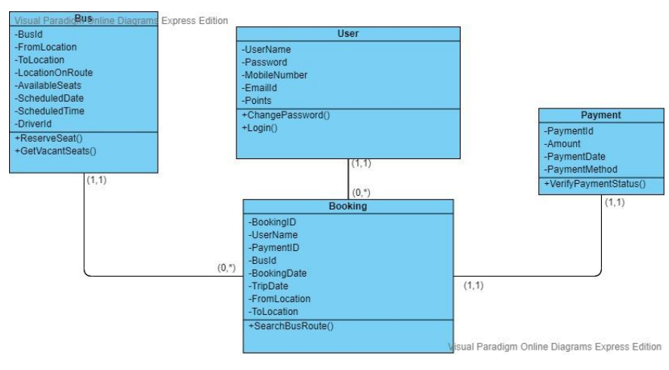

## **9.2. Class diagram for Get Bus Schedule use case**

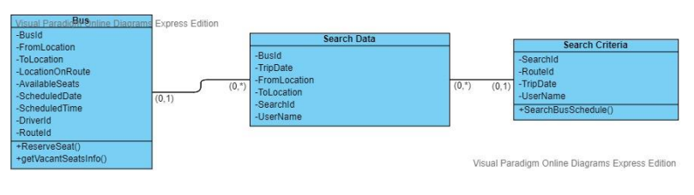

## **9.3. Class diagram for Driver Check In – Check Out use case**

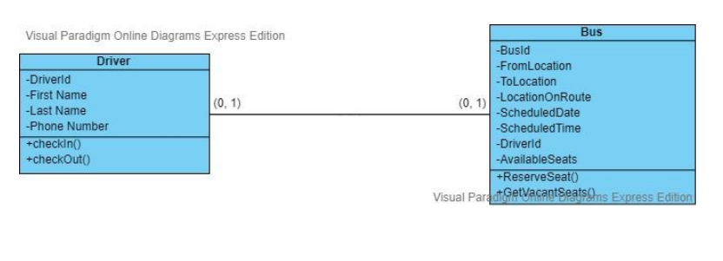

## **9.4. Class diagram for Apply Promo Code use case**

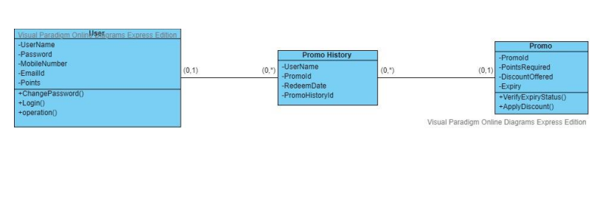

# **10. SEQUENCE DIAGRAMS**

## **10.1. Main Sequence diagram**

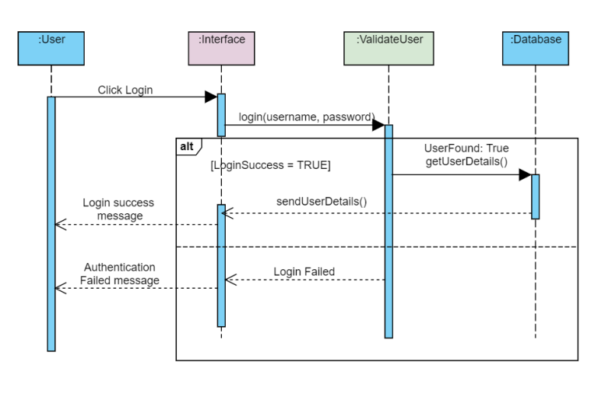

## **10.2. Sequence diagram for Reserve A Seat use case**

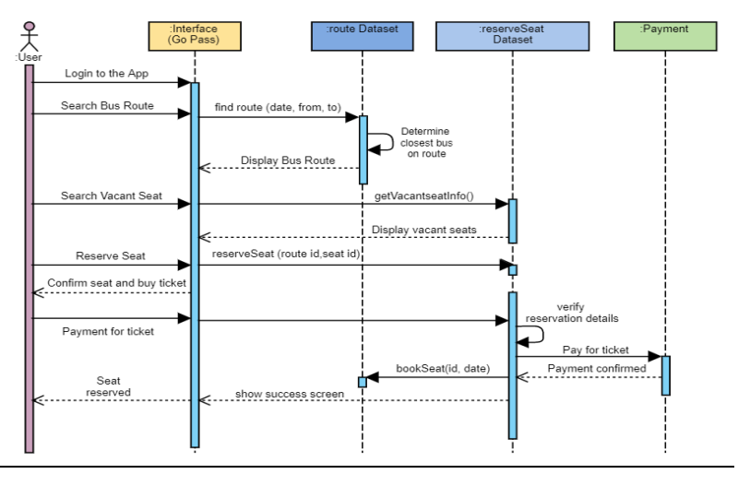

## **10.3. Sequence diagram for Get Bus Schedule use case**

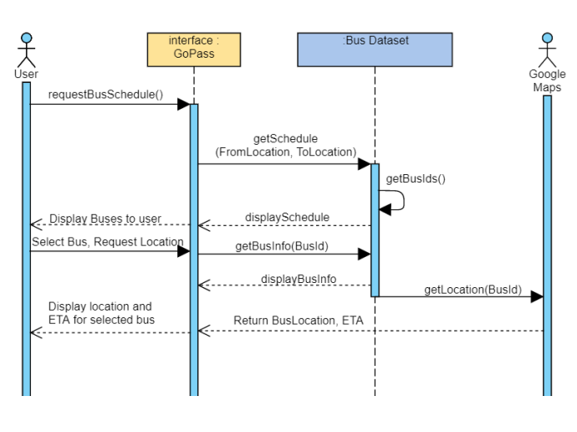

## **10.4. Sequence diagram for Driver Check In – Check Out use case**

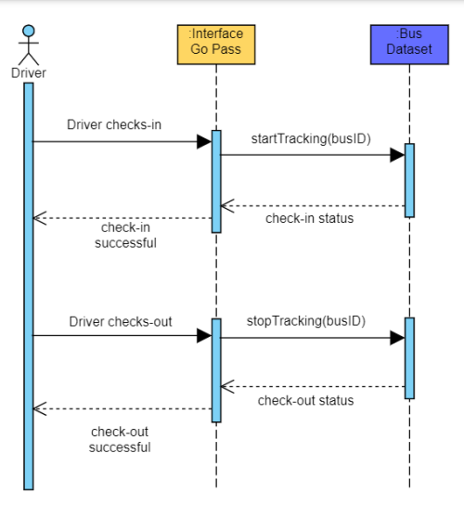

## **10.5. Sequence diagram for Apply Promo Code use case**

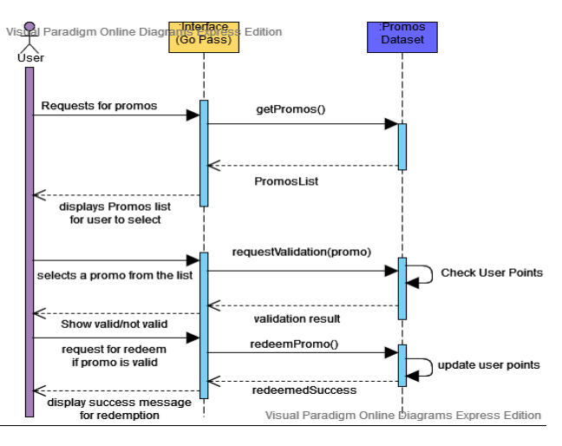

# **11. INTERFACE DESIGN**

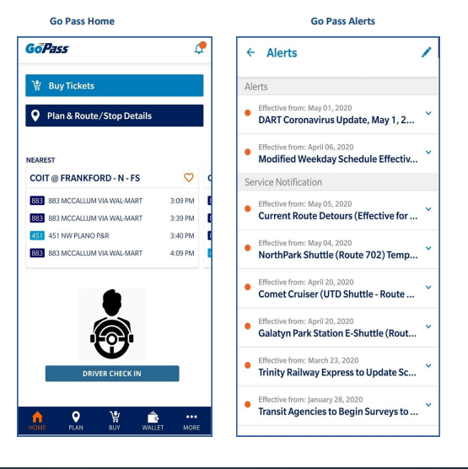

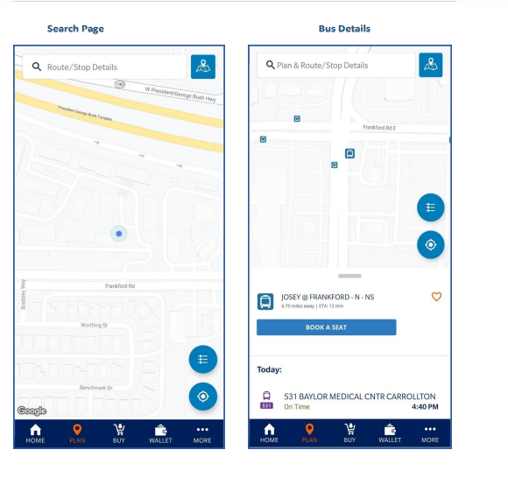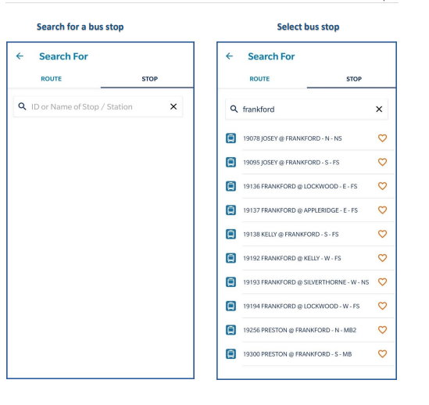

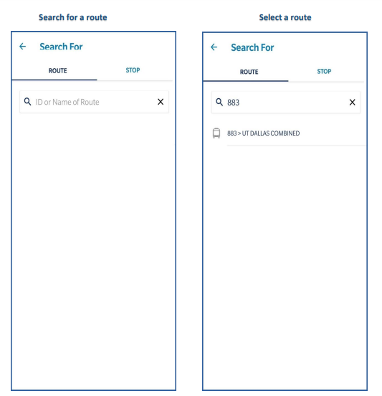

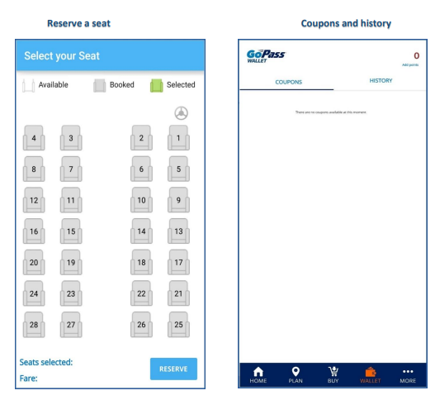

# **12. COMPLETE CLASS DIAGRAM**

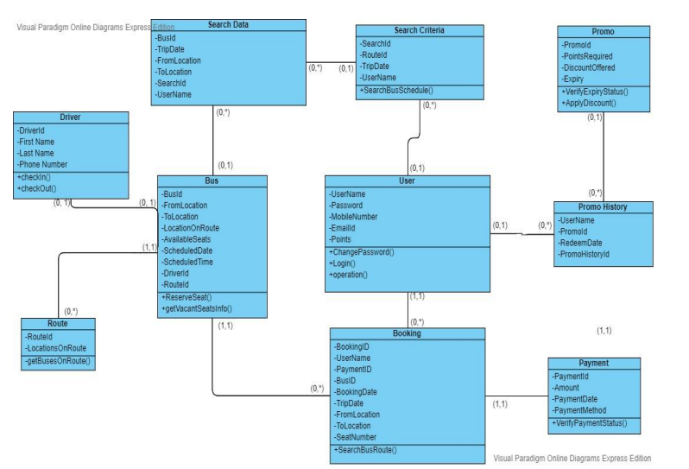

# **13.DATABASE DESIGN**

## **13.1. Entity Relationship Diagram**

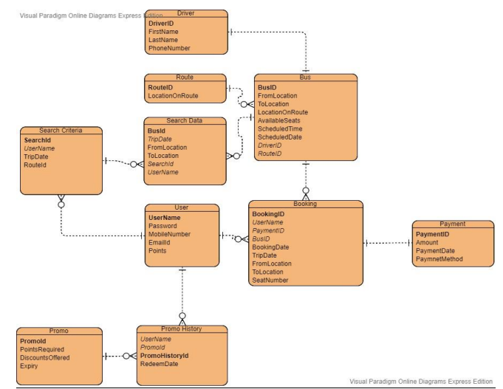

## **13.2. Database Constraints**

• User(UserName,Password,MobileNumber,EmailId,Points)

• SearchCriteria(SearchId,UserName,TripDate,RouteId)

SearchCriteria.UserName references Username

• SearchData(BusID, TripDate,FromLocation,ToLocation,SearchId,UserName)

SearchData.UserName references User.UserName

SearchData.SearchId references SearchCriteria.SearchId

• Payment(PaymentID,Amount,PaymentDate,PaymentMethod)

• Route(RouteID, LocationOnRoute)

Route.RouteID not null

• Driver(DriverID,FirstName,LastName,PhoneNumber)

• Bus(BusID,FromLocation,ToLocation,LocationOnRoute,AvailableSeats,ScheduledTime,Sc

heduledDate,DriverID,RouteID)

Bus.DriverID references Driver.DriverID

Bus.RouteID references Route.RouteID

• Booking(BookingID,UserName,PaymentID,BusID,BookingDate,TripDate,FromLocation,To

Location,SeatNumber)

Booking.UserName references User.UserName

Booking.PaymentID referenres Payment.PaymentID

Booking.BusID references Bus.BusID

Booking.UserName, Booking.PaymentID, Booking.BusID not null

• Promo(PromoId,PointsRequired,DiscountOffered,Expiry)

• PromoHistory(PromoHistoryId,UserName,PromoId ,RedeemDate)

PromoHistory.PromoId references Promo.PromoId

PromoHistory.UserName references User.Username

# **14. SOFTWARE DESIGN**

**Signature**

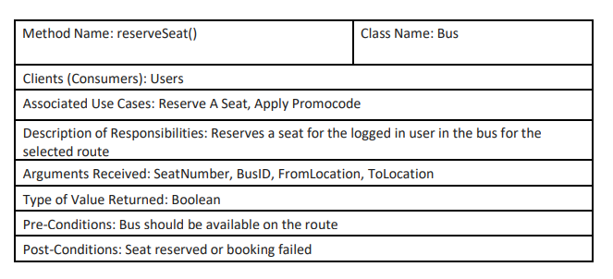

**Logic:**

1. FETCH bus details for the BusID

2. IF seat with SeatNumber is vacant in the bus

a. Create new booking for logged in user and set BusID, SeatNumber, tripDate, FromLocation and ToLocation

b. RETURN True and redirect user to payment ENDIF

3. ELSE SeatNumber is not empty

a. RETURN False and redirect user to select seat page.

ENDELSE

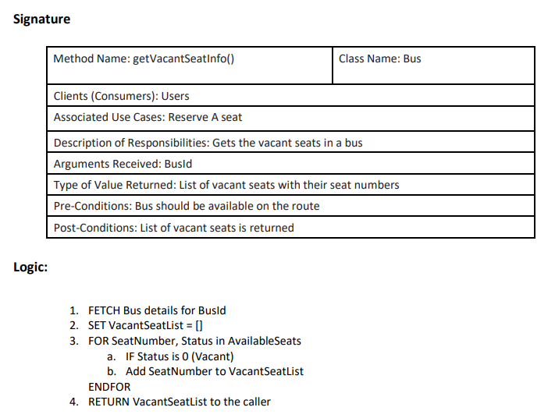

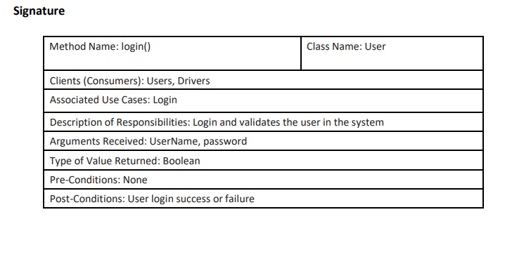

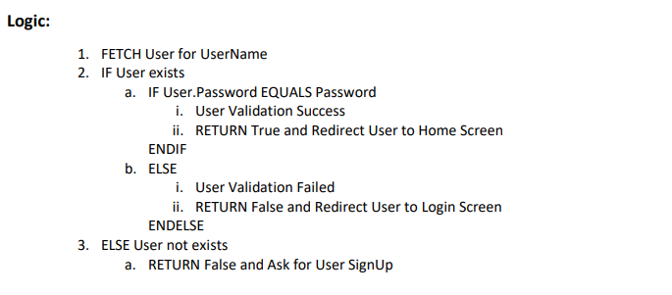

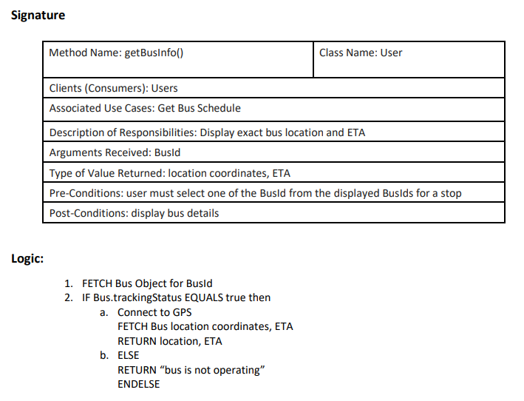

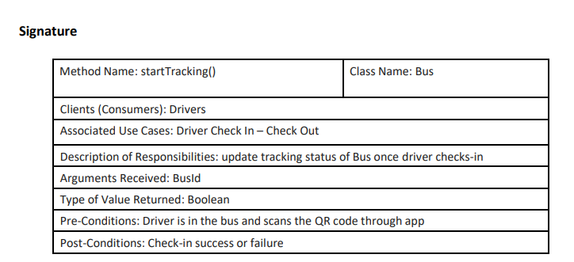

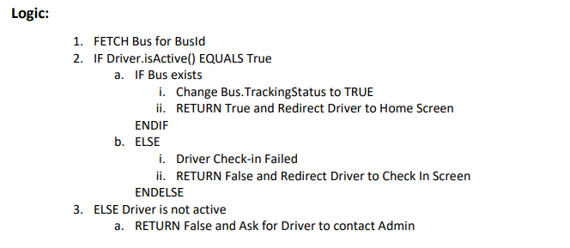

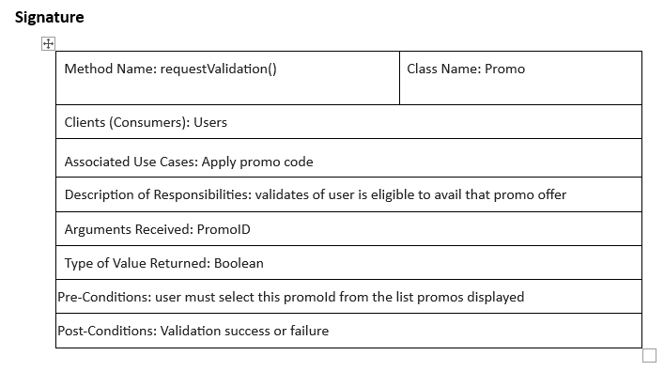

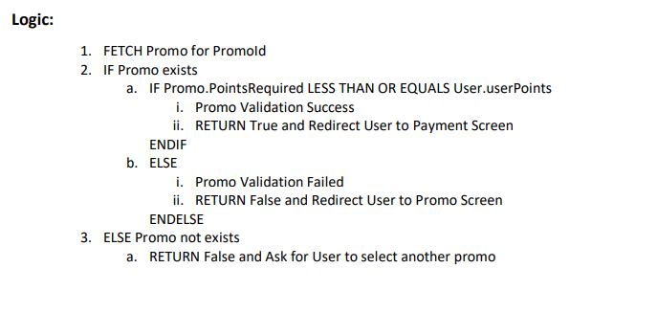

# **15.Project Management Deliverables**

## **15.1. Minutes of meeting and Weekly Tasks**

• Meeting for Group 1

• Meeting type: SAPM project discussion.

**Project Activities Member Assigned to**

Executive Summary: Nikhil Sai Vemula

Problem Statement: Monika Vaddineni

BPMN: Monika Vaddineni

Context Diagram: Nikhil Sai Vemula

Use Case Diagram and Descriptions: Sriya Namavarapu

Sequence Diagram: Monika Vaddineni

Class Diagram (without methods): Sriya Namavarapu

Complete Class Diagram: Sriya Namavarapu

Functional Specification Document: Nikhil Sai Vemula

Data Structure Notation: Nikhil Sai Vemula

Interface Design: Monika Vaddineni

Database Design: Monika Vaddineni

Software Design: Sriya Namavarapu

Project Management Deliverables: Sriya Namavarapu

|  |  |  |  |  |  |
| --- | --- | --- | --- | --- | --- |
| **Project Activities/discussed topics:** | **Planned Date/Meeting:** | **Execution**  **Date/ Week:** | **Attendees and task allocation:** | **Meeting summary:** | **Next action/ meeting date:** |
| Exchange emails and phone **numbers** | iWeek 1 | Week 1 | Monika Vaddineni  Sriya Namavarapu  Nikhil Sai Vemula | _ | 10/29/2023 |
| Learn about the team and have a talk about the project's deliverables and requirements before choosing a system to work on. | Week 2 | Week 2 | Monika Vaddineni  Sriya Namavarapu  Nikhil Sai Vemula | Talk about the project needs, including the scope, mobility, and IOT. | _ |
| Project Idea Brainstorming: Minimum of 1 Idea per person. | 10/29/2023 | 10/29/2023 | Monika Vaddineni  Sriya Namavarapu  Nikhil Sai Vemula | Discussion of various concepts and their suggested enhancements, such as remote cleaning services, online pharmacy systems, the 7-Eleven app, bus notification systems (Go pass), etc. | 11/1/2023 |
| Finalized on  “go pass- improvements  ” | 11/1/2023 | 11/1/2023 | Monika Vaddineni  Sriya Namavarapu  Nikhil Sai Vemula | completed the Go Pass app, had a thorough talk on system upgrades, and decided on the tools we will utilize. | 11/5/2023 |
| Documentation problem and proposed idea | 11/5/2023  , | 11/5/2023 | Monika Vaddineni  Sriya Namavarapu  Nikhil Sai Vemula | discussed and recorded the present system and problem description, clarified the project's scope, and recorded the functional and business requirements, as well as the project's goals. |  |

|  |  |  |  |  |  |
| --- | --- | --- | --- | --- | --- |
| Scope, business requirements |  |  | Monika Vaddineni  Sriya Namavarapu  Nikhil Sai Vemula | Problem statement, Objectives.    Business requirements and scope and functional specifications | 11/8/2023 |
| Context diagram | 11/8/2023 | 11/8/2023 | Monika Vaddineni  Sriya Namavarapu  Nikhil Sai Vemula | discussed the system's modules and created a context diagram | 11/11/2023 |
| Figure out the people and steps involved and make a process map. | 11/11/2023 | 11/11/2023 | Monika Vaddineni  Sriya Namavarapu  Nikhil Sai Vemula | Discussed the actors, use cases designed the business processes | 11/15/2023 |
| Design a Usecase Diagram and Write a Use-case description. | 11/15/2023 | 11/15/2023 | Monika Vaddineni  Sriya Namavarapu  Nikhil Sai Vemula | Designed the use cases and use case descriptions | 11/19/2023 |
| Write data dictionary | 11/19/2023 | 11/19/2023 | Monika Vaddineni  Sriya Namavarapu  Nikhil Sai Vemula | Remaining use case descriptions and a documented data dictionary | 12/22/2023 |
| Design class diagrams and sequence diagrams | 12/22/2023 | 12/22/2023 | Monika Vaddineni  Sriya Namavarapu  Nikhil Sai Vemula | created class and sequence diagrams and talked about process flows, methods, hierarchies, and classes. arranged and combined the system's class diagrams. | 11/25/2023 |

|  |  |  |  |  |  |
| --- | --- | --- | --- | --- | --- |
| Design database diagrams and identify database constraints | 11/25/2023 | 11/25/2023 | Monika Vaddineni  Sriya Namavarapu  Nikhil Sai Vemula | Tables were normalized and database restrictions were identified. created and integrated the system's database design. | 11/27/2023 |
| Interface design | 11/27/2023 | 11/27/2023 | Monika Vaddineni  Sriya Namavarapu  Nikhil Sai Vemula | discussed and created the app's user interface and displays.  responsibilities assigned to document the report. | 11/30/2023 |
| Documentation of methods and pseudo code | 11/30/2023 | 11/30/2023 | Monika Vaddineni  Sriya Namavarapu  Nikhil Sai Vemula | Logic and method validations went into its design.    the program, design, and controls were documented. | 12/2/2023 |
| Project report documentation  first draft | 12/2/2023 | 12/2/2023 | Monika Vaddineni  Sriya Namavarapu  Nikhil Sai Vemula | organized and integrated all of the individual documentation | 12/4/2023 |
| Report Final draft | 12/4/2023 | 12/4/2023 | Monika Vaddineni  Sriya Namavarapu  Nikhil Sai Vemula | Final adjustments and improvements to the documentation added to the project deliverables. | 12/6/2023 |
| Final proofread and report documentation completion and submission | 12/6/2023 | 12/6/2023 | Monika Vaddineni  Sriya Namavarapu  Nikhil Sai Vemula | Final additions in project deliverables and final proofread    Project submission. | _ |

# 

# **16. REFERENCES**

<https://www.masstransitmag.com/technology/passenger-info/mobile-applications/pressrelease/21130224/dallas-area-rapid-transit-dart-dart-to-license-gopass-to-mtta>

<https://www.geeksforgeeks.org/project-idea-bus-notification-system-using-crowdsourcing/?ref=>

<https://online.visual-paradigm.com/w/phmtdquv/diagrams/#proj=0&type=SequenceDiagram>

<https://www.dart.org/>